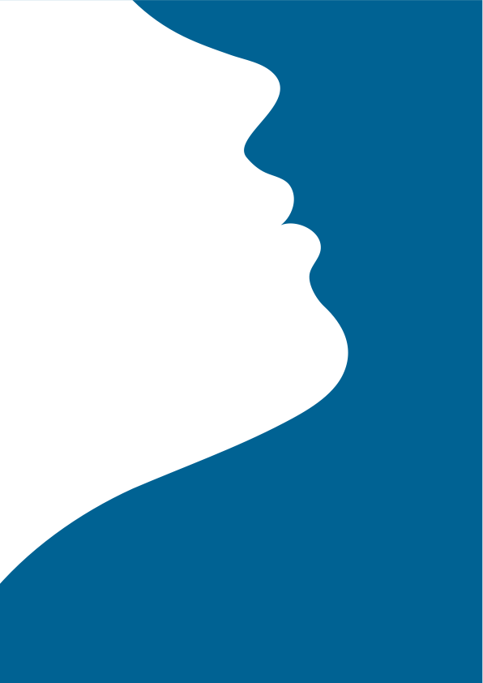
Save Face
Luxira

Botulinum Toxin Patient Information (Upper Face)

Botulinum Toxin Patient Information

What is Botulinum Toxin?

Botulinum toxin is a naturally occurring protein produced by the bacterium Clostridium Botulinum. In a purified form,; as is the case with many drugs/medications such as Penicillin, Botulinum toxin is a very safe, effective treatment not only used in cosmetic clinics, but also for a number of medical conditions, including migraine and excessive sweating.

All botulinum toxins are prescription only medicines (POM) and can only be prescribed by doctors, dentists and nurses with the prescribing qualification, following a face to face assessment and consultation with the qualified prescriber.

Botox® is a licensed brand of Botulinum toxin A. Other licensed brands include Azzalure®, Dysport®, Xeomin® Bocouture® .

Botulinum toxins contain albumin, which comes from human blood. No cases of contamination of licensed botulinum toxin products with infectious diseases have been reported.

How does it Work?

The toxin blocks the transition of chemical messages from the nerve to the muscle so that the muscle stays in a resting state for a period of 8 to 12 weeks on average.

This may be only a partial reduction in movement allowing some remaining movement or a full block in which case there is very little remaining muscular movement in the area – this very much depends on the amount administered and location of product placement –treatment may be tailored to suit your individual requirements. Your expected treatment outcomes and whether they can be achieved will be discussed at the time of consultation.

Used to Treat

The aim of the licensed treatment is to significantly reduce the movement of the muscles causing expression lines (dynamic lines) specifically the frown and crow’s feet and worry lines on the brow may also be treated as an ‘off label indication. Successful treatment may not cause the expression lines themselves to disappear completely. It may not ‘completely freeze’ the expression, particularly if extreme effort is exerted to make an expression.

Botulinum toxin is not suitable for lines present without expression (static lines), your practitioner will advise you.

Advanced and off-label indications include; horizontal brow lines, lip lines, chin ‘poppling’, muscles on the lower face and neck, to lift the mouth corners, improve the jaw line and the appearance of the neck. The ‘chewing muscle’ may also be treated to soften a square jaw or to prevent teeth grinding or jaw clenching at night.

How Long will it Last?

Results tend to last 3-4 months. Movement will begin recovering from 8 weeks. Frequent treatment at intervals of less than 3 months is not recommended. Repeating treatment when movement recovers will deliver optimum results over time. Frequency of treatments may be reduced according to the quality of your skin and your response to treatment. Should you choose not to maintain the results and not have further treatment, your muscles and skin will return to their pre-treatment state.

Does it Hurt?

A very fine needle is used and generally this treatment is not described by most as painful and can be well tolerated with no anaesthetic. Please request an anaesthetic cream or ice, if you are nervous about needles.

Before Treatment

It is important you tell your practitioner about any medicines or dietary supplements you are taking, some medicines can adversely affect the way the toxin works or increase your risk of bruising.

If you are taking supplements such as Vitamin A, C or E, Gingko Biloba, Garlic, fish oils, St. Johns Wort or some pain killing medicines such as aspirin or ibuprofen, then these can increase your risk of bruising and it may be advisable to stop taking them a few days before your treatment. It is also advisable that you do not drink alcohol the night before your treatment, for the same reason.

It is not advisable to have treatment if you are feeling at all unwell.

Make-up will need to be removed prior to the injections and you will be advised not to reapply it for 12 hours in order to reduce the risk of infection or irritation at the injection sites.

Be aware of the necessary after care advice and that your schedule allows for you to follow it.

After Treatment

You will be advised to keep the target muscles active for a few hours and to avoid extremes of heat or cold, vigorous exercise, lying down or leaning over for 4-6 hours.

After treatment it is expected that you will start to see an improvement within 2 or 3 days. For some people this takes longer. The full result may be judged at 2-3 weeks. You will be invited to attend a review appointment at 2-3 weeks where the success of the treatment may be assessed and adjustments to your personal treatment plan made, if necessary.

Should you experience any unexpected side effects or any that concern you, please contact the clinic.

Botulinum Toxin administration can result in anaphylaxis (a severe allergic reaction) which in itself is life threatening and requires immediate medical attention. Symptoms of a severe allergic reaction can include shortness of breath, wheezing, coughing, difficulty swallowing, swelling of the tongue, eyelids, lips, hoarseness of the voice, stomach pain, nausea or diarrhoea. If you have any of the above symptoms please report to your nearest Accident and Emergency Department or call 999 for an ambulance.

Feedback

We are accredited by Save Face, a voluntary register of clinics such as ours. The accreditation process is robust and provides independent, third party validation and verification of our qualifications, safety and quality of care and service.

Your feedback and testimonials help others to select/judge our service and enable us to audit our practice and ensure we maintain standards.

